7.2.1 Editors - 3D View - Header - View Menu
All Modes - View Menu 2
Toggle Full screen Area 2
Toggle Maximize Area 2
Toggle Quad view 3
Duplicate Area into New Window 3
View All 3
Center Cursor and View All 3
View All all Regions 3
View Selected 4
View Selected All Regions 4
View Global / Local 4
Render Border 4
Clear Render Border 5
Clipping 5
Clear All Restrict Render 5
Restrict Render Unselected 6
Set Restrict Render 6
Align View to Active 6
Align View 6
Align Active Camera to View 6
Align Active Camera to Selected 6
Center View to Cursor 7
View Lock to Active 7
View Lock Center 7
View Lock Clear 7
View Persp/Ortho 7
Top, Bottom, etc. 7
View Camera Center 7
Active Camera 8
Set Active Object as Camera 8
OpenGL Render Animation 8
OpenGL Render Image 8
Tool Shelf 9
Properties 9

All Modes - View Menu

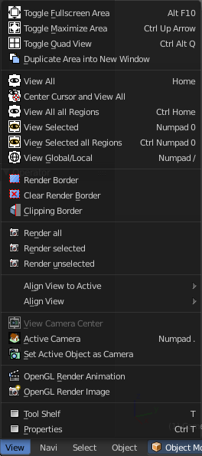
The View menu contains all View related tools. The range goes from tools to maximize the current window across align view tools up to rendering related tools for the viewport like Render Border.

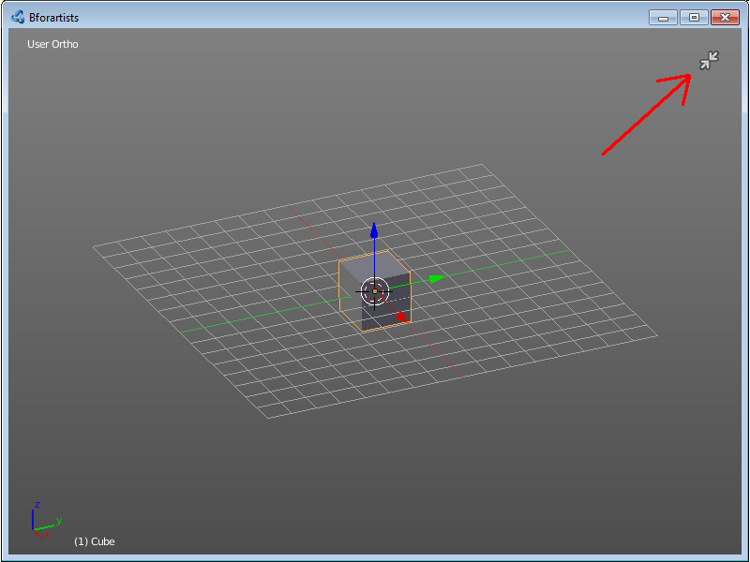
Toggle Full screen Area
Displays the editor maximized without menus.
To return from the full screen view press hotkey Alt F10, or use the little button that appears up right when you move the mouse in this corner.

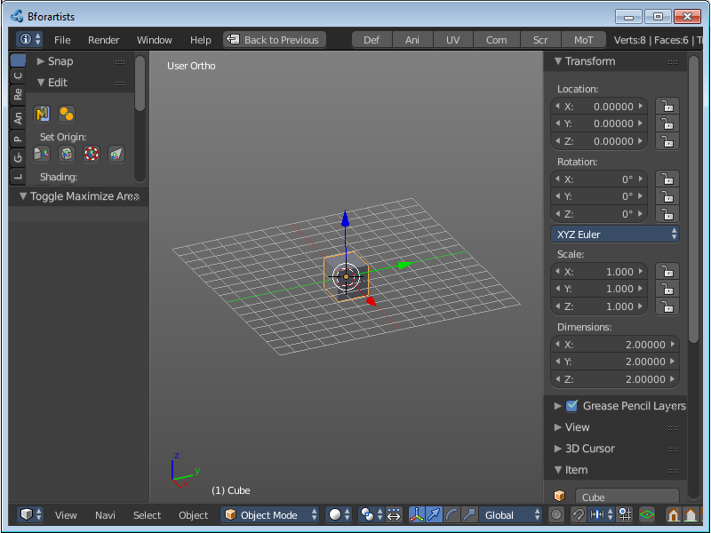
Toggle Maximize Area
Displays the editor maximized with menus.
To return to split view press hotkey Ctrl Up Arrow, or reuse the menu item in the View menu.

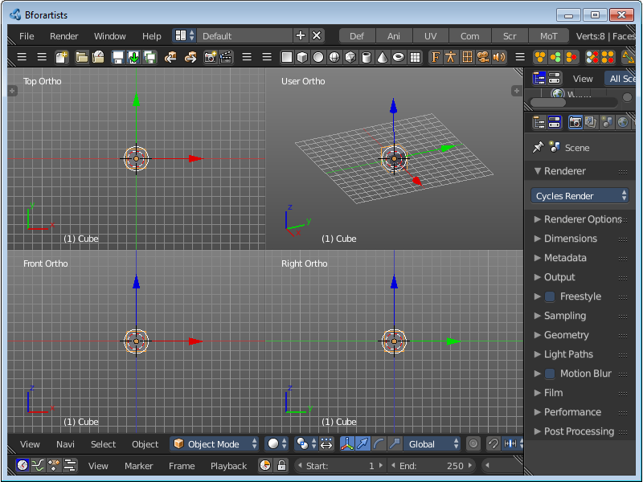
Toggle Quad view
Displays the 3D View divided into four screen parts.
To return to single view reuse the menu item in the View menu.

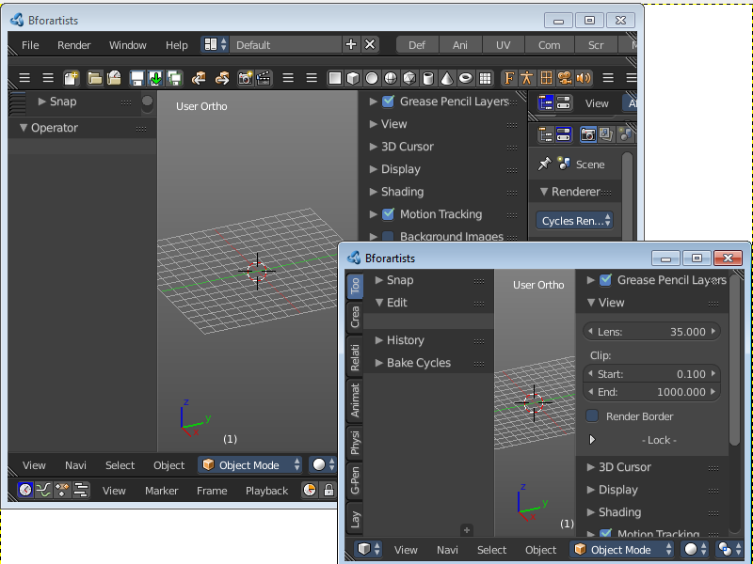
Duplicate Area into New Window
Duplicate Area into New Window makes the selected editor window floating. You can then drag it around at the monitor.
A separated window cannot be merged into the main window again. You have to close it when not longer needed.

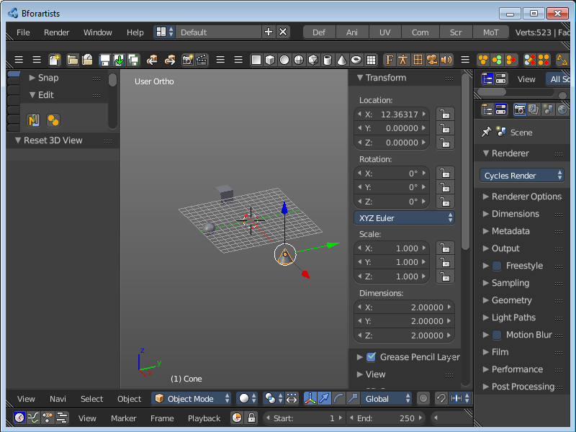
View All
View all zooms in or out until all objects in the scene are displayed fitting in the viewport.

Center Cursor and View All
Center Cursor and View all centres the 3D Cursor at 0/0/0, and zooms in or out until all objects in the scene are displayed fitting in the viewport.

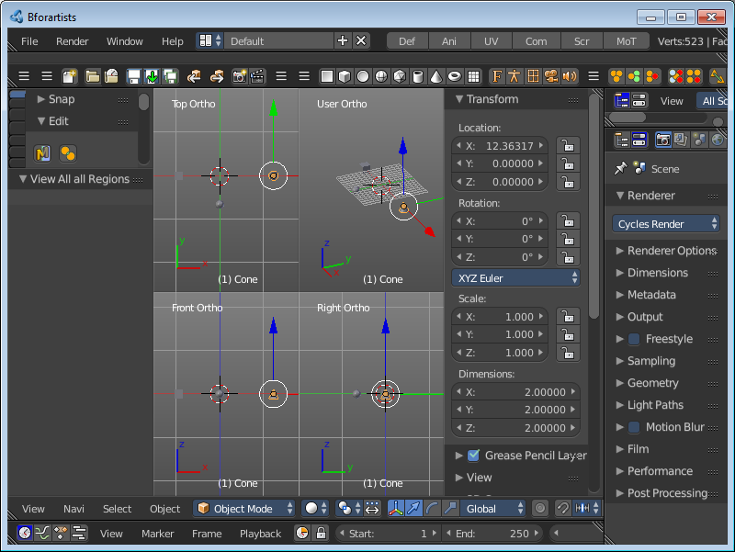
View All all Regions
View All all Regions works just in Quad View. It zooms in or out until all objects in the scene are displayed fitting in the four divided parts of the viewport.

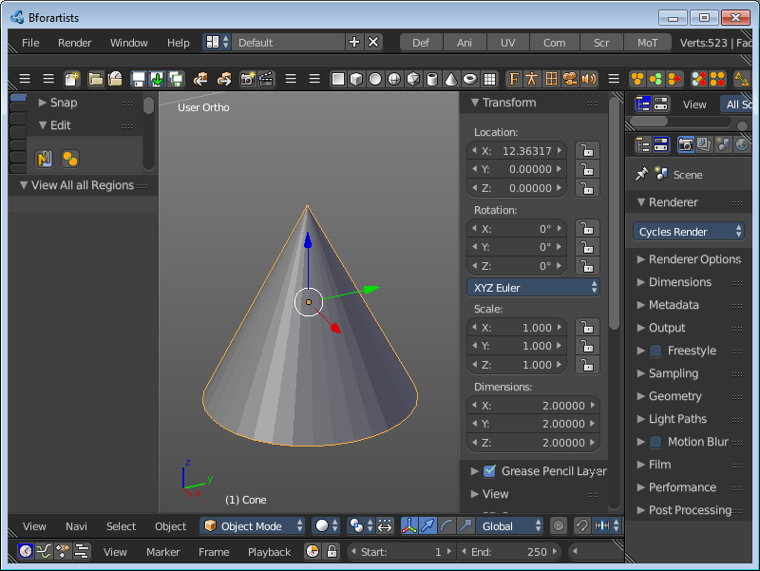
View Selected
View Selected zooms in or out until the Selection is displayed fitting in the viewport.

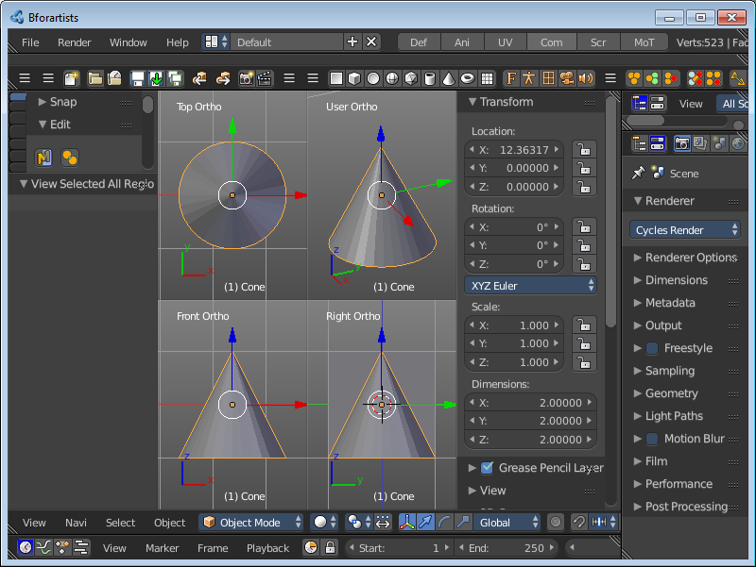
View Selected All Regions
View Selected all Regions works just in Quad View. It zooms in or out until the Selection in the scene are displayed fitting in the four divided parts of the viewport.

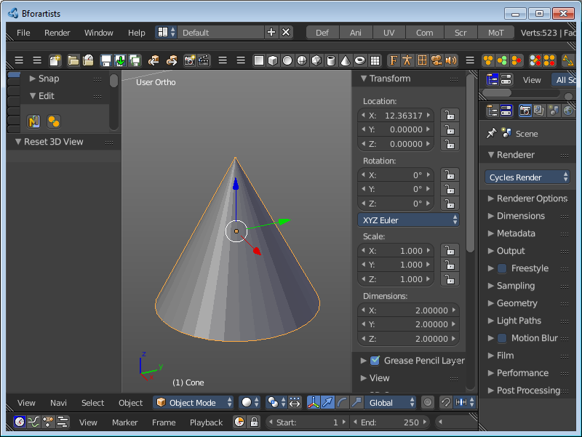
View Global / Local
View Global / Local zooms in or out until the Selection is displayed fitting in the viewport. And hides all other objects but the Selection.

Render Border
With the Render Border you can drag a rectangle at the viewport to define a portion of the screen to render. The benefit here is to have much faster preview renderings. You just render what you want to judge, and not the whole image.
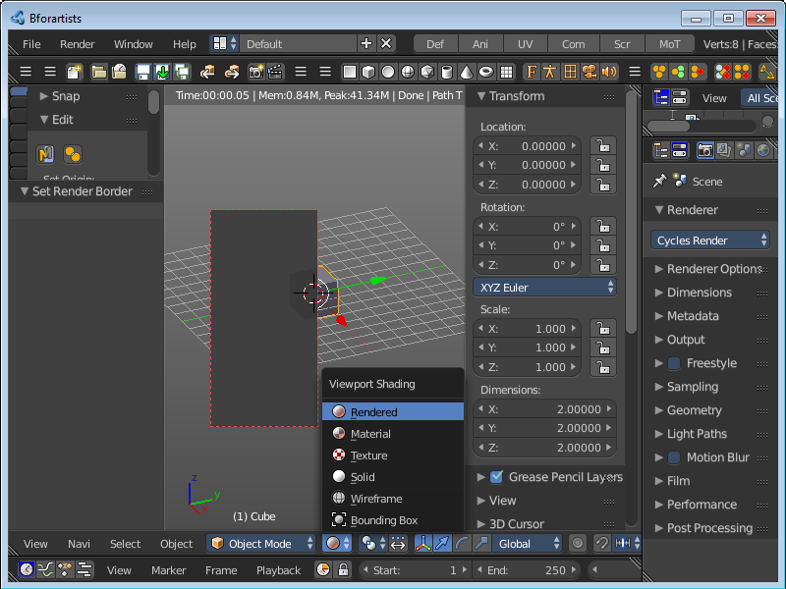
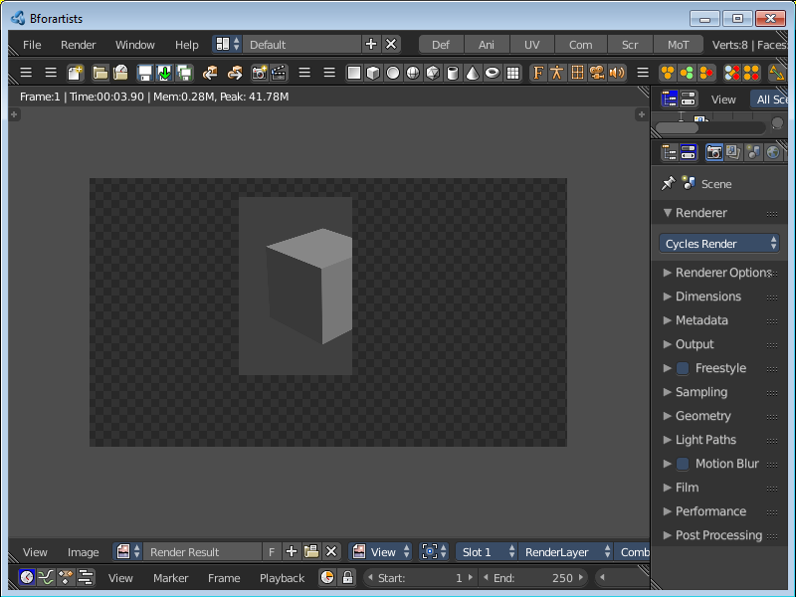
It has two use cases. The one is with the rendering through the camera. Just what is marked gets rendered. The other is directly in the viewport, with the Viewport shading method Rendered.

Clear Render Border
Removes the Render Border from the viewport.

Clipping
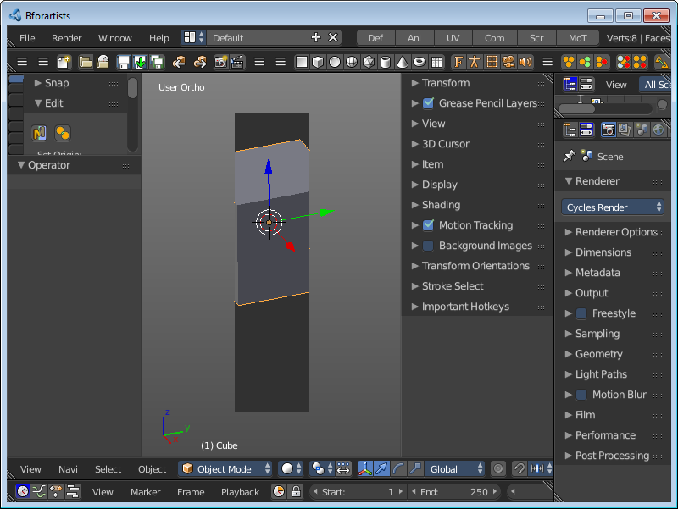
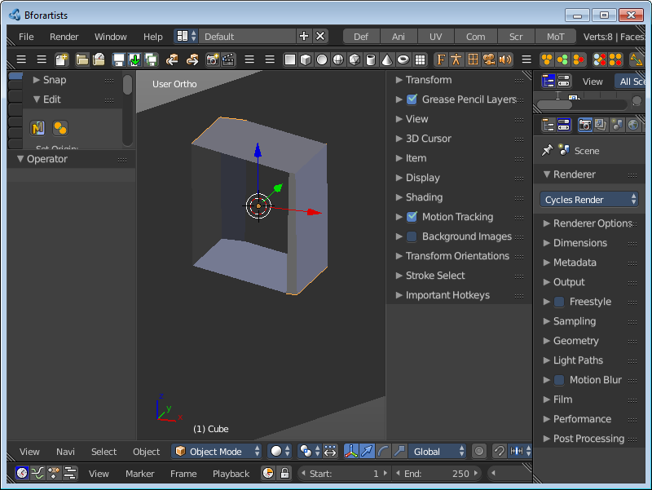
With clipping you can draw a rectangle that excludes the display of everything outside of this rectangle. That way you can look inside the geometry when you rotate the viewport. To clear the clipping use the tool again.

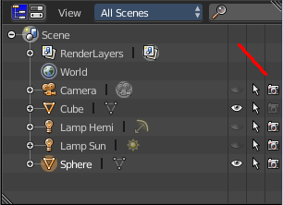
Clear All Restrict Render
Sets all Objects in the scene to be rendered. Have a look in the outliner, the camera row at the right.
This menu option just appears when there is a render able object in the viewport.

Restrict Render Unselected
Sets all unselected Objects in the scene to be rendered. The selected object(s) will be excluded from rendering now. Have a look in the outliner, the camera row at the right.
This menu option just appears when there is a render able object in the viewport

Set Restrict Render
Sets the selected Objects in the scene to be rendered. The unselected objects will be excluded from rendering now. Have a look in the outliner, the camera row at the right.
This menu option just appears when there is a render able object in the viewport

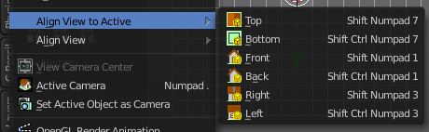
Align View to Active
Align View to Active is a menu where you can choose between different view align methods. The view gets aligned relative to the rotation of the currently active object. Not in World coordinates. The menu items should be self explaining. So we won't list them one by one.

Align View
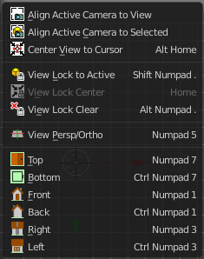
Align View is a menu where you can choose between different view align methods. The view gets aligned at the world coordinates. Here we also find a few more align methods.

Align Active Camera to View
Aligns the active camera to the current view. This means you can navigate with the viewport camera, select the render camera, and align it with this tool, so that the render camera has the same position and angle than the viewport camera.

Align Active Camera to Selected
Aligns the active camera to the current selected object. This means you can navigate with the viewport camera, select the render camera, and align it with this tool, so that the render camera has the same position and angle than the selected object.

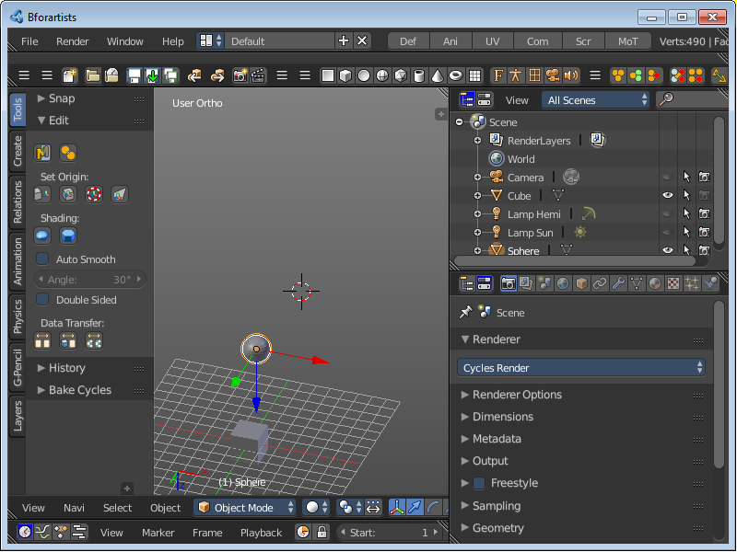
Center View to Cursor
Centres the view at the 3D cursor position.

View Lock to Active
Locks the view to the currently active object.

View Lock Center
Centres the view to the currently active and locked object. This tool is just active when you have performed a View Lock to Active before.

View Lock Clear
Removes the View Lock to Active from the object.

View Persp/Ortho
Toggles between perspectivic and orthographic view. Perspectivic view acts like a real camera with the perspectivic distortions. Orthographic view acts like a mathematical display of an object, without distortions.
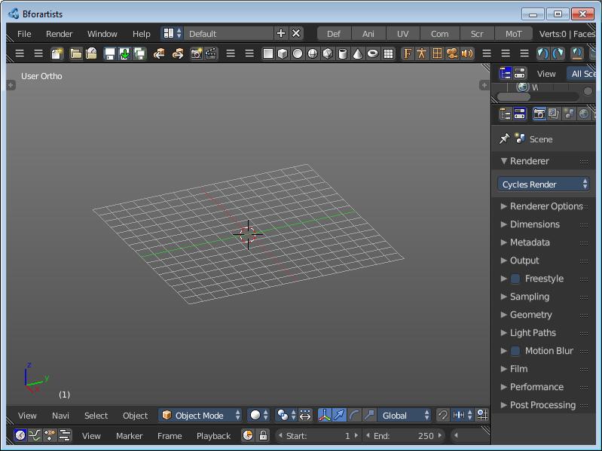
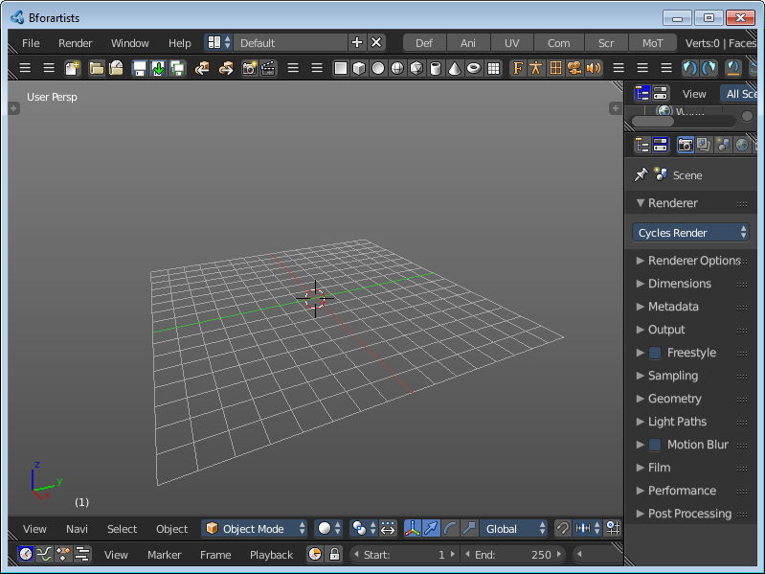

Top, Bottom, etc.
Switches to Top view, Bottom View, etc.

View Camera Center
This tool is of use when you are in camera view. It can be that the passepartout around the actual camera view field does not fit into the viewport. It can be too big or too small. It's already enough to resize the Tool shelf at the left or the Properties Sidebar at the right. And then it doesn't fit anymore.
View Camera center fits the camera view into the viewport.
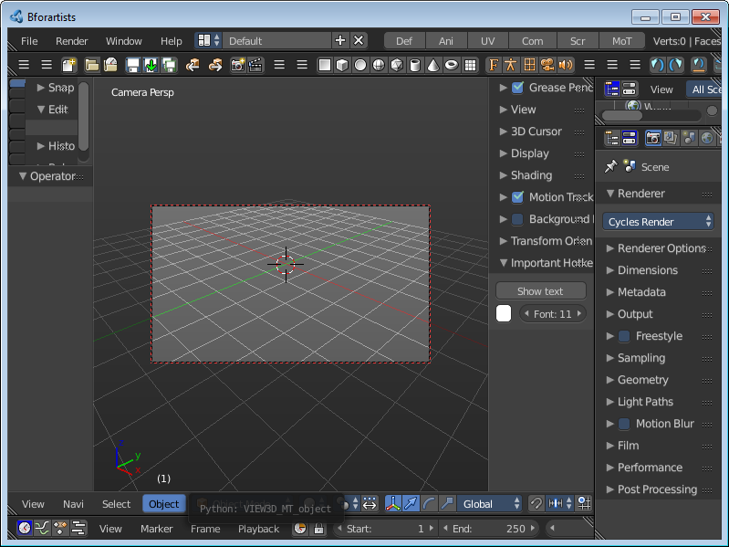
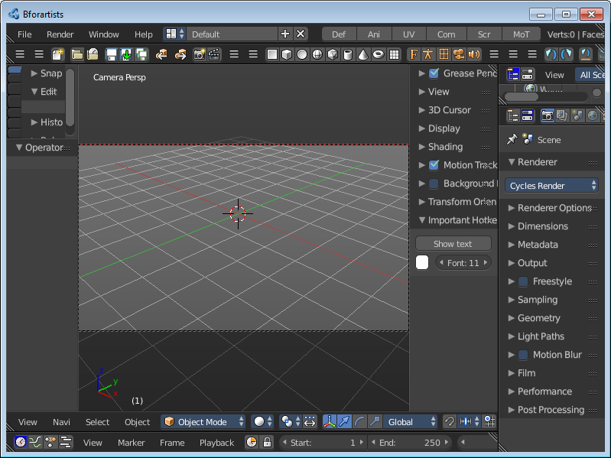

Active Camera
Switches to Camera view and back to Viewport Camera.

Set Active Object as Camera
With this tool you can set any object to be the active camera where you render from.

OpenGL Render Animation
Renders an animation, using the Viewport OpenGL renderer. This can be useful for preview renderings.
Note
Note that this menu item is a double menu entry. The same menu item exists in the Render menu in the Info Header. But this is required when you work with more than one 3D view. When you use the entry in the Render menu, then it picks an arbitrary 3D view. When you use the menu entry in the 3D view, then it renders from this 3D view.

OpenGL Render Image
Renders an Image, using the Viewport OpenGL renderer. This can be useful for preview renderings.
Note
Note that this menu item is a double menu entry. The same menu item exists in the Render menu in the Info Header. But this is required when you work with more than one 3D view. When you use the entry in the Render menu, then it picks an arbitrary 3D view. When you use the menu entry in the 3D view, then it renders from this 3D view.

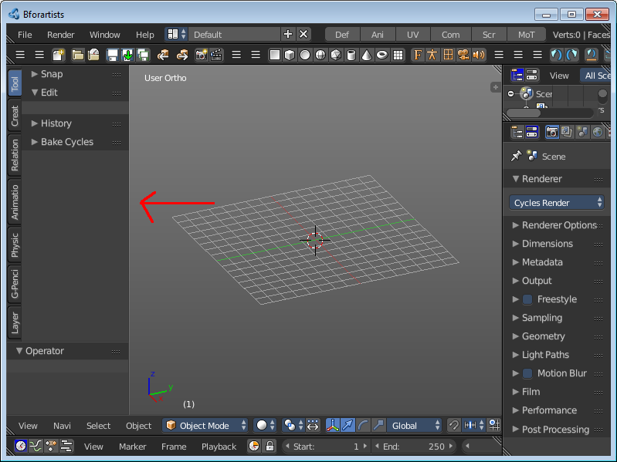
Tool Shelf
Opens or closes the Tool Shelf at the left side of the 3D Viewport.

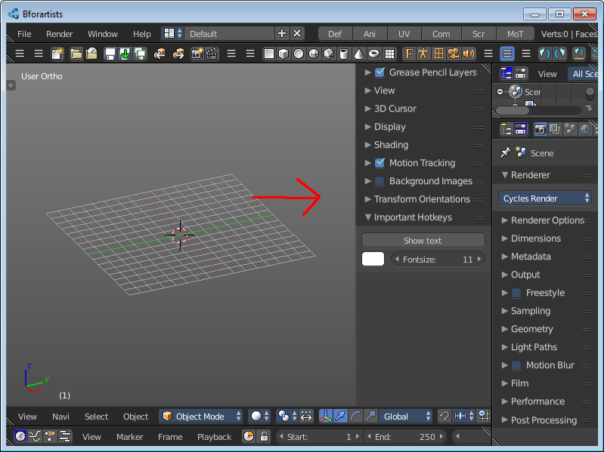
Properties
Opens or closes the Properties sidebar at the right side of the 3D Viewport.

